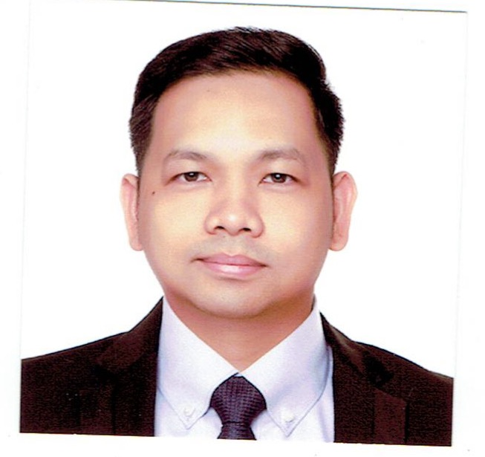

Attach Here

2x2

Colored Picture

**Warren Roque Enverga**

Block 6 Lot 9 Glenmont Subd., Sauyo Road, Novaliches, Quezon City

Philippines, 1116

Mobile No.: (63 )917-5076198

Email Add: [wynenverga@gmail.com](mailto:wynenverga@gmail.com)

**PERSONAL INFORMATION**

Permanent Address : Block 6 Lot 9 Glenmont Subd. Sauyo Road, Novaliches, Quezon City, Philippines, 1116

Birthdate : March 9, 1981

Birth Place : Mandaluyong City

Height : 5’7 ft.

Weight : 170 lbs.

Sex : Male

Civil Status : Married

Religion : Roman Catholic

Nationality : Filipino

**EDUCATIONAL BACKGROUND**

**Elementary**  **Year [From] - [To]**

School: Bagong Silang Elementary School 1988 - 1994

Address: Bagong Silang Caloocan City

**Secondary**

School: Metro Manila College 1994 - 1998

Address: Novaliches, Quezon City

**College**

Course: Electronics & Computer Technology 1999 - 2001

School: Asian College of Science and Technology

Address: Novaliches, Quezon City

**EMPLOYMENT HISTORY**

Position: **Server/Supervisor/Restaurant Manager-OIC**

Company: Italiannis Restaurant

Address: Trinoma Mall, Quezon City, Philippines

Date: November 2004 – August 2020

Reason for Leaving: Resigned

Job Description / Duties and Responsibilities:

* Working with Director for Officer, develop the restaurant’s annual operating budget and control all profit and loss centers, including food, beverage, supply, utility and labor costs.
* Ensure safe working environment to reduce the risk of injury and accidents through continual repair and maintenance of restaurant
* Maintain an accurate and up-to-date manpower plan of restaurant staffing needs. Prepare management schedules and ensure that the restaurant is staffed for all shift
* Staff, train and develop restaurant managers and hourly employees through orientations, ongoing feedback, establishment of performance expectations and by conducting performance reviews.
* Responsible in maintaining an A Plus service to the guests by means of enhancing guests relation through serving high quality product in a fast and efficient service and making the guest feel at home.

Position: **Server/Waiter/Bartender**

Company: Ratstky Bar and Restaurant

Address: Tomas Morato St., Timog Avenue, Quezon city

Date: August 2003 – August 2004

Reason for Leaving: Resigned

Job Description / Duties and Responsibilities:

* In charge of order taking and delivering of food in a very friendly, fast and efficient manner without sacrificing the quality of food
* A constant top seller in terms of suggestive selling of wine and other alcoholic beverages which is one of the top contributors to the bar sales.

**TRAININGS / SEMINARS ATTENDED**

Training Center: The Bistro Group Duration: April 21, 2015

Address: 9727 Kamagong St., Brgy. San Antonio Village, Makati City, Philippines

Title: Train the Trainer

Training Center: The Bistro Group Duration: April 06, 2016

Address: 9727 Kamagong St., Brgy. San Antonio Village, Makati City, Philippines

Title: Coaching Skill Workshop

Training Center: The Bistro Group Duration: July 08, 2019

Address: 9727 Kamagong St., Brgy. San Antonio Village, Makati City, Philippines

Title: Leadershape

Training Center: The Bistro Group Duration: January 28, 2020

Address: 9727 Kamagong St., Brgy. San Antonio Village, Makati City, Philippines

Title: Store visit

**SPECIAL SKILLS / INTERESTS**

* Skilled in food preparation of Filipino and Italian dishes
* Driving skill and Carpentry
* Well-versed in oral and written English and Filipino.
* Hiking mountains

**CHARACTER REFERENCES**

Ms. Mary Ann Santiago

Director for Operation

Italiannis Philippines

Tel. No.: (63) 0915-3915567

Ms. Thess Alejandrino

Director for Operation

The Bistro Group

Tel No.: (63) 0917- 8274651

_________________________

Applicant’s Signature